

**PROJECT TITLE:** ONLINE ANIMAL RESCUE AND CARE SYSTEM

**Course Name: SOFTWARE ENGINEERING**

**Section: G**

**Group No: 1**

GUIDED BY

FARZANA BENTE ALAM

Department of Computer Science

American International University-Bangladesh (AIUB)

PREPARED BY

|  |  |  |
| --- | --- | --- |
| **No** | **NAME** | **ID** |
| 1 | RIYAD HOSSAIN AKAND | 18-36736-1 |
| 2 | AL SAMEU HOSSEN | 18-37921-2 |
| 3 | NAYIM, MD AL MUZAHID | 18-38056-2 |
| 4 | TASLIMA TABASSUM TONNI | 18-38548-2 |

**INTRODUCTION:**

A survey showed that every year about 1.2 million animals got injured in road accident all over the world where some of them died on the spot and many of them got injured forever because of not getting treatment in time. So after doing the research on this problem we have decided to make an application that can help us to rescue this animal as early as possible when animal injured.

**OBJECTIVE:**

The main objective of this project is to make the process easier for them who want to help any injured animal or want to adopt an animal from animal care center. It's easy to find a dog or cat who's right for you at a shelter or rescue group. But helping an animal find a forever home doesn’t have to be complicated. With the advantage of new technologies, such as mobile phone applications, identifying an animal to adopt no longer needs to be such a protracted process. So, if someone is looking for a [cat](http://www.onegreenplanet.org/animalsandnature/awesome-reasons-to-adopt-a-cat-video/) or [dog](http://www.onegreenplanet.org/news/this-dogs-journey-proves-shelter-animals-are-not-broken/) of a specific breed, size, age, or temperament, they should look no further than the smartphone in their hands.

**TERGET USRES:**

* General people- people can send immediate rescue request if they find injured animal and also can adopt the animal of their choice by searching in application.
* Local animal rescue and care centers- they can get update from people to rescue and can also add pet’s information so that people can easily adopt animal from them.

**PROJECT DISCRIPTION**:

This application will help people to contact with local animal rescue and care center instantly. When people find any injured dog, cat or other animals in street they can take picture immediately or add some information about the animal and upload that into our application. This application will work as via between the general people and some animal rescue and care center. So after getting information about injured animal rescue team will take action immediately. People can also adopt their favorite animal with the help of this application. Animal care and rescue center can upload their available animal’s details in this application so that the customers can find it and communicate with them for adopting. So here the rescue centers will be benefitted too. So this application can be a feasible solution to meet their business idea. The basic functionality of this application will be very user friendly and easily understood. There are some key features of our application for user:

**Rescue request:** user can upload necessary information and request for rescue if he finds any injured animal.

**Search:** It's easy to find a dog or cat who is right for you at a shelter or rescue group. Simply user can enter their zip code above to start search.

**Contact:** Once user find a pet and click "learn more about me" to get contact info for their shelter or rescue. Contact them to learn more about how to meet and adopt the pet.

**Adopt:** The rescue or shelter will walk user through their adoption process. People will prepare their home for the arrival of the dog or cat to help them adjust to their new family.

**Basic functional requirements of this software:**

**Rescue request:**

* At first user have to create an account by providing necessary information (phone no, email, address, new password). And then they have to login first for using this application.
* For doing rescue request for an animal user have to click on ‘rescue request’. Then they have to add information such as location details, present condition or accidental issue etc. into given ‘text box’ and they can also attach photo by clicking ‘add picture’ button. Then by clicking ‘send rescue request’ button all this information will be uploaded to the system.
* As nearer rescue team will be connected with this application they will get this information and by clicking ‘accept’ button they can let the requester know that they are coming to rescue that animal. The rescue center can also turn on the alarm option into the application to be informed about instant rescue request.

**Search:** when user will search they can see many different types off animal there. Then they can easily find cat dog whoever they need.

* when user choose more than one animal then they have to add to cart first then order together.
* If someone like animal & they live far away. Then they will book them & animal will be sent to them after verification.

**Contact:** Once user find a pet and click "learn more about me" to get contact info for their shelter or rescue.

* **learn more about me:** To contact with us user can check into the " learn about me" info page. To click on info page then they can find contact helpline which is divided in to three section. One section is about Medical treatment, second is shelter and another is about rescue the animal.
* **Medical treatment**: If animal needs any medical treatment users can contact easily with doctor by using our application.
* **Shelter:** If users wants to give shelter an orphan animal they can contact us with via helpline number, message or emails.

**Adoption request:** To adopt their favorite animal user have to fill up form for sending request.

* **From Fill Up**: Into the online form users have to add their Credit card, National ID card number, home address details, personal mobile number, email and send the request. That information will be verified by the system.
* if the request is approved by the animal care center the user can select any one of two process:

**Hand to hand delivery:** User will select this option if they want to come to the office.

**Home delivery:** If users are busy then they can select home delivery by clicking ‘home delivery’ button.

* **Payment:** for conform delivery user have to do 50% payment. For home delivery, delivery cost will be added and that will be calculated by the system depending on the distance.

**Use Case Diagram of “Online animal rescue and care center”:**

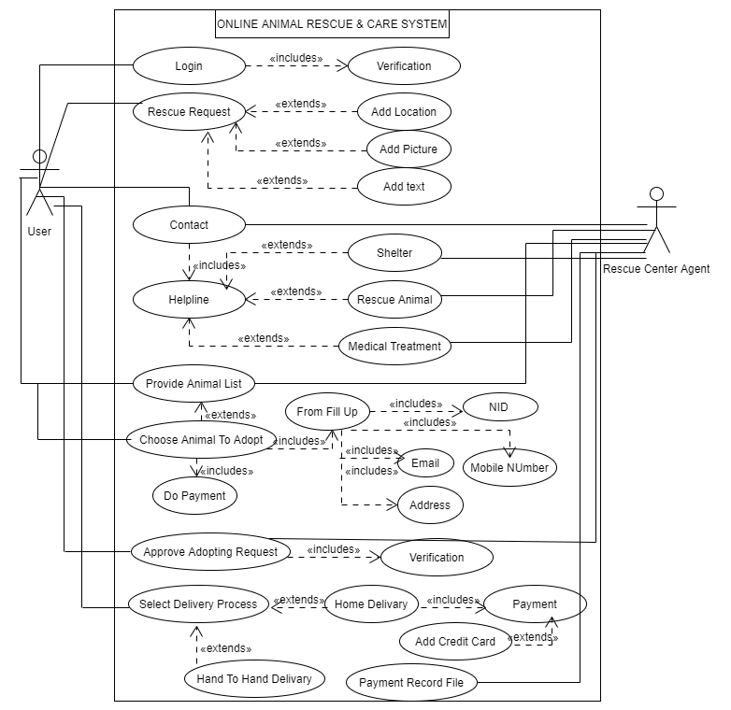

**Class diagram of “Online animal rescue and care center”:**

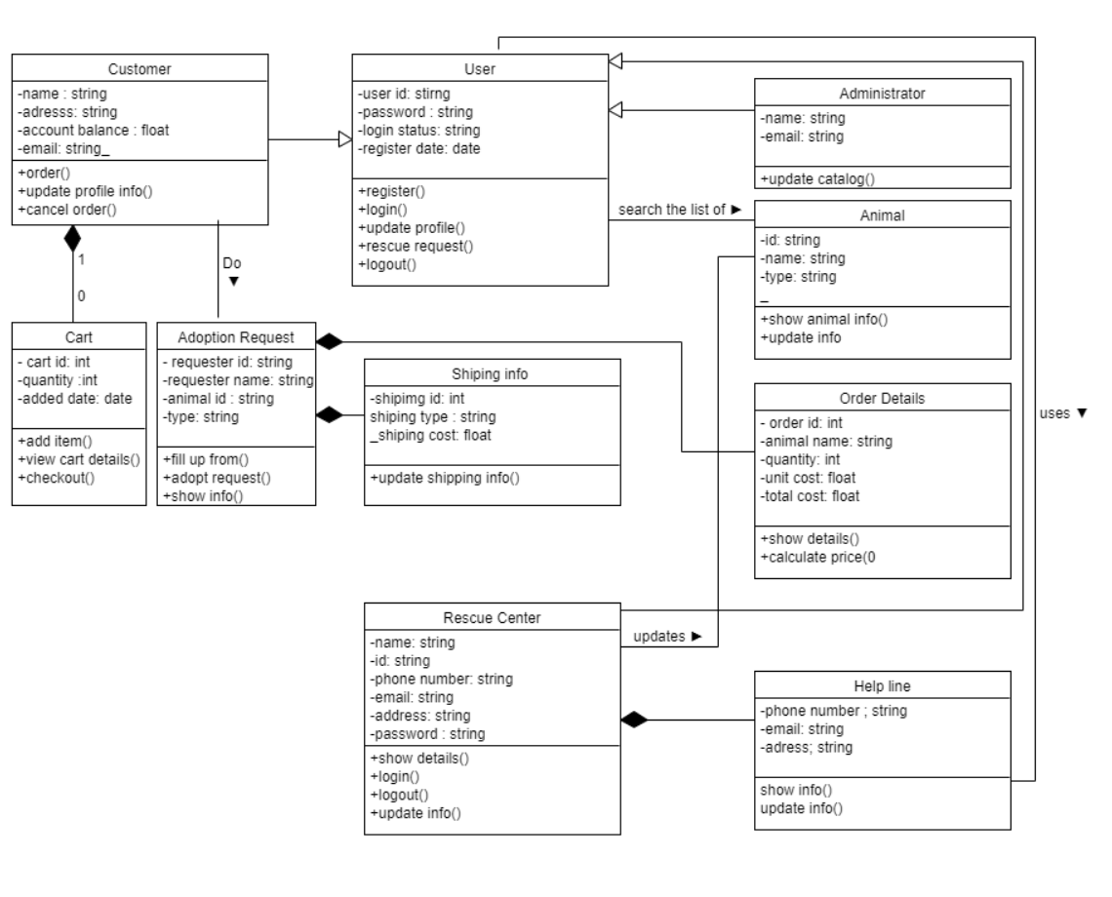

**Sequence diagram of ‘Online Animal Rescue and Care Center’**

In ‘Online animal rescue and care center’ software we have two main process.

Sequence diagram of rescue request process:

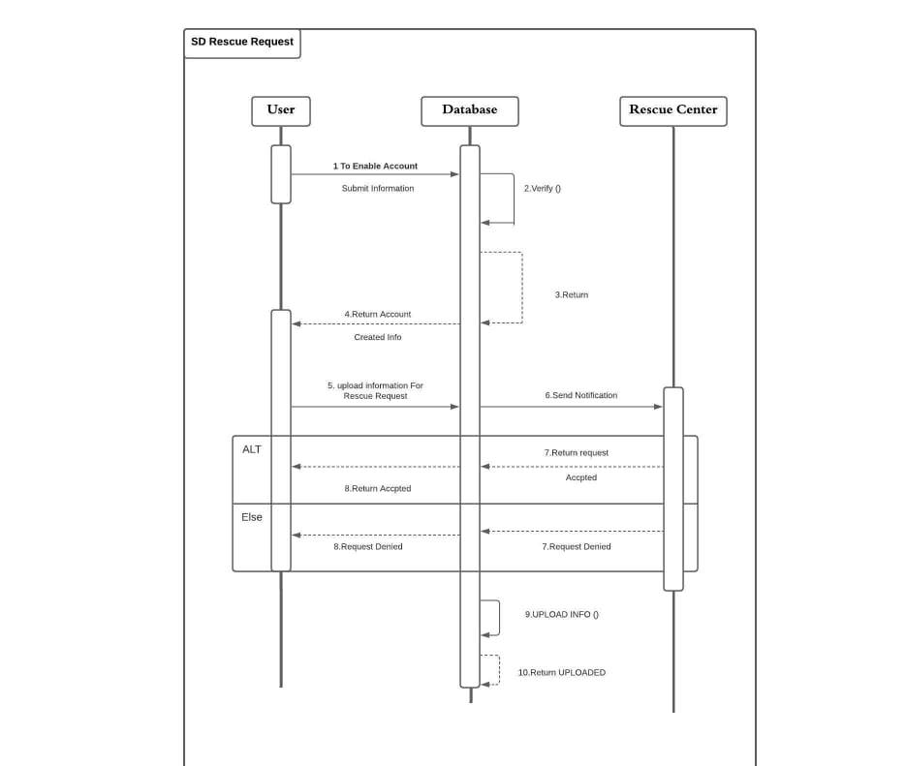

**Sequence diagram of animal adoption process:**

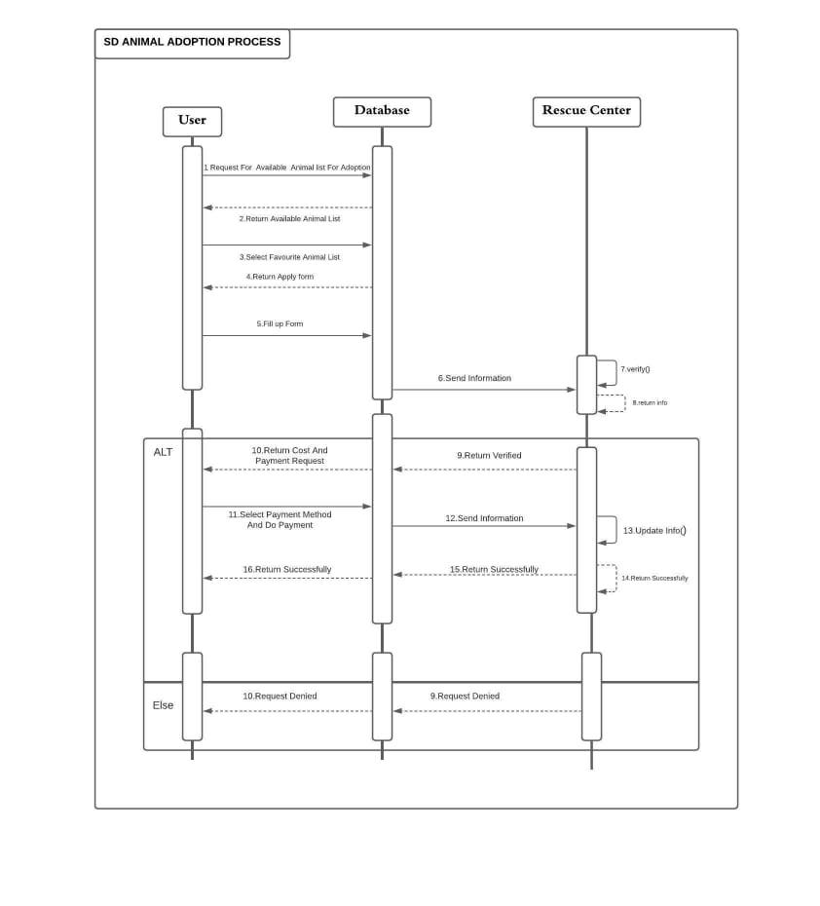

**Activity diagram of ‘Online animal rescue and care center’:**

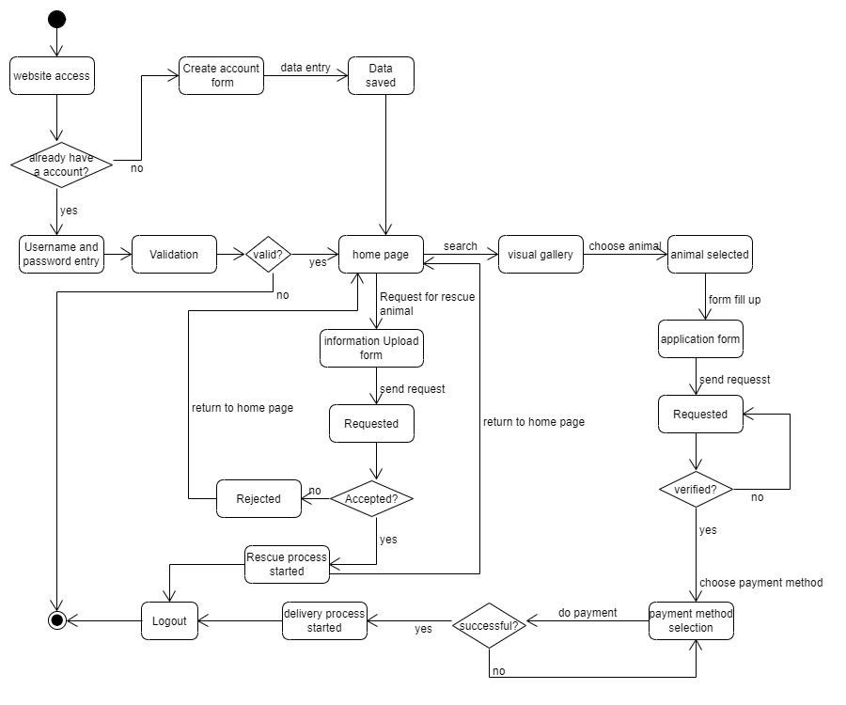

**Software process model selection**

**The model that we selected:**

We have done study on given Software process models and selected SCRUM model for our proposed ‘Online animal rescue and care center’ system solution.

**Reason behind selecting this model:**

SCRUM method is the best choice among all other methods to develop your proposed software because it helps to save time and money. With the division and assignment of roles and tasks efficiently, this methodology helps us work successfully on a project. We can release useable product to users and customers in a short time with higher quality and higher productivity in Lower costs. It has greater ability to incorporate changes as they occur. Better employee morale. Better user satisfactory. This method can be used to complete complex projects that previously could not be done. Scrum method will help us to complete project deliverables quickly and efficiently rather than other software development model. Scrum ensures effective use of time and money. As our project is a large project so we can divide our project into easily manageable sprint by using SCRUM method. It will make our work much easier. In our project we have to keep direct collaboration with the client. And scrum also supports these criteria. Daily scrum meeting enables the team to be in sync on how things are going and provides an opportunity for small course corrections within the sprint. High visibility of progress can be seen for this. This is the reasons behind selecting the SCRUM method for developing our software.

**Roles:**

**Scrum Master:**

Scrum Master is responsible for ensuring the project is carried through according to the practices, values, and rules of Scrum and that it progresses as planned. Our team, customer and management will interact with Scrum Master.

**Product Owner:**

Our product owner responsible for project, controlling and product backlog list. He will be selected by the Scrum Master, the rescue center representative, and the management. He makes the final decisions of the tasks related to product Backlog.

**Scrum team:**

Our scrum team and authority decided on the necessary actions and order to achieve goals of each sprint. This team will be involved in effort estimation, creating the Sprint Backlog, reviewing the product Backlog list and suggesting impediments that need to be removed from the project.

**Customer:**

Our customer of this software is the animal rescue organization. They will participate in the tasks related to product Backlog items for the system being developed. Receives and verifies the final product.

**Management:**

Our management will be in charge of final decision making, the agreements, standards, and conventions to be followed in the project. They will also help for setting the goals and requirements of this project.

**User Interface of ‘Online Animal Rescue and Care Center’**

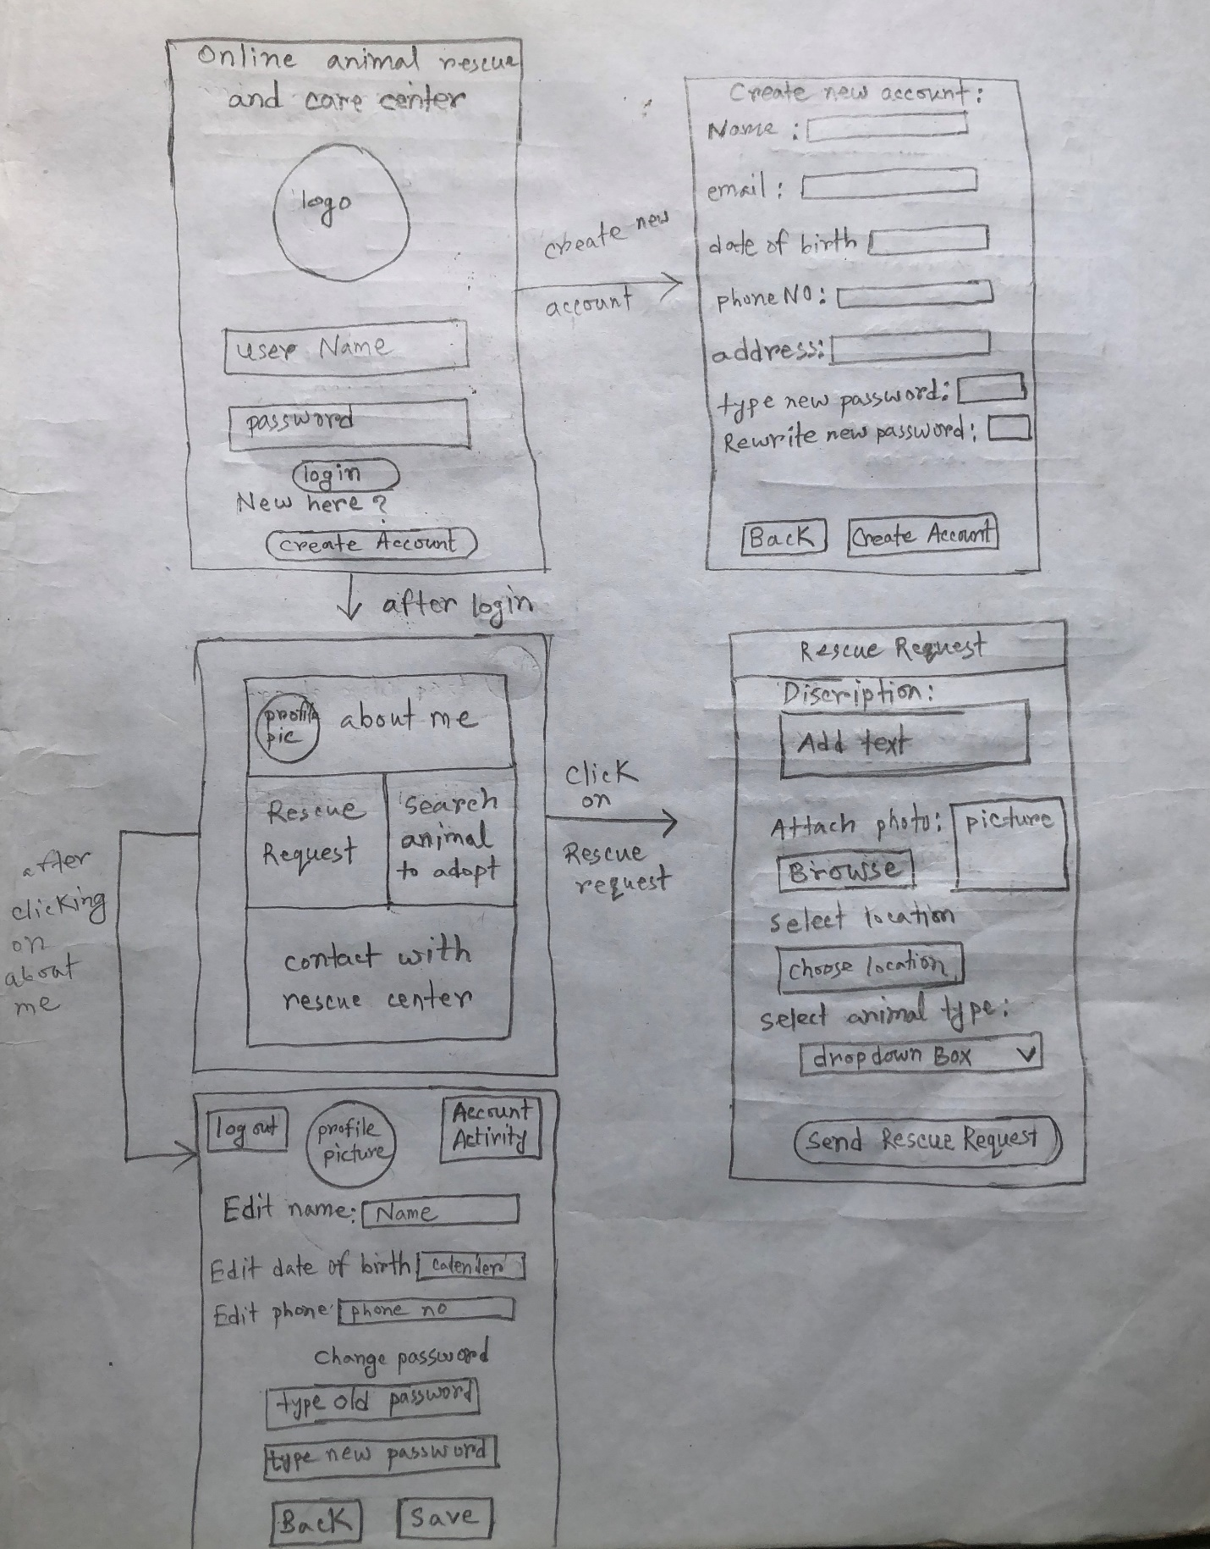

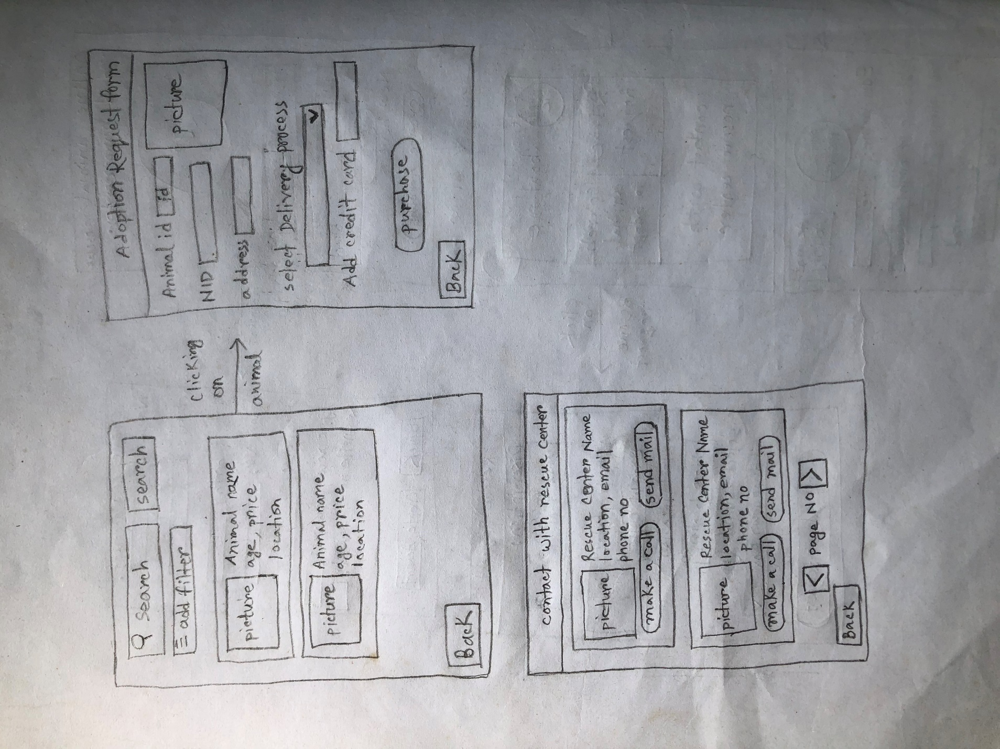

|  |  |  |  |  |  |
| --- | --- | --- | --- | --- | --- |
| Project Name: Online Animal Rescue and Care center | | | Test Designed by: Developers | | |
| Test Case ID: SE_1 | | | Test Designed date: | | |
| Test Priority (Low, Medium, High): Medium | | | Test Executed by: Developers | | |
| Module Name: Login Session | | | Test Execution date: | | |
| Test Title: verify login with valid username and password | | | | | |
| Description: Test website login page | | | | | |
| Precondition: User must have valid username and password | | | | | |
| Test Steps | Test Data | Expected Results | | Actual Results | Status (Pass/Fail) |
| 1. Go to the website 2. Enter username 3. Enter password 4. Click Login | Username: Nayim  Password: 123 | User should login into the application | | As expected, | Pass |
| Post Condition: User is validated with database and successfully login to account. The account session details are logged in the database. | | | | | |

**Selected testing technique for the ‘Online animal Rescue and Care Center’ project:**

**White-Box testing**

**Why we chose White-Box Testing in our project:**

White-Box Testing is a type of testing where the tester can see the code. The main purposes of this type of testing are to test the inner workings of the software, as well as strengthen its security, and improve its usability and design. White-Box Testing is software testing technique in which internal structure, design and coding of software are tested to verify flow of input-output and to improve design, usability and security. It’s counterpart, Black-box testing, involves testing from an external or end-user type perspective. The advantages of White-Box Testing are it helps in optimizing the code. As the tester has knowledge of the source code, it becomes very easy to find out which type of data can help in testing the application effectively. Extra lines of code can be removed which can bring in hidden defects. Due to the tester's knowledge about the code, maximum coverage is attained during test scenario writing. White-box testing assures code functionality and makes later, higher level testing less time intensive. Thorough black box testing enhances end user experience. For this reasons we find White-box testing is a better option and that’s why we use it in our project.

|  |  |  |  |  |  |
| --- | --- | --- | --- | --- | --- |
| Project Name: Online Animal Rescue and Care center | | | Test Designed by: Developers | | |
| Test Case ID: SE_2 | | | Test Designed date: | | |
| Test Priority (Low, Medium, High): Medium | | | Test Executed by: Developers | | |
| Module Name: Sign up Session | | | Test Execution date: | | |
| Test Title: verify the sign up process for creating new account. | | | | | |
| Description: Test website Sign up page | | | | | |
| Precondition: User must have a valid email and phone number. | | | | | |
| Test Steps | Test Data | Expected Results | | Actual Results | Status (Pass/Fail) |
| 1. Go to the website 2. Click on Create a new Account 3. Enter Name, email, Date of Birth, phone number, address, new password, Rewrite password 4. Click Create Account | Username: Nayim  Email: [nayim@gmail.com](mailto:nayim@gmail.com)  Phone no:  55767677886  Address: Dhaka  Password: 123 | User should create a new account. | | As expected, | Pass |
| Post Condition: User is validated with database and successfully login to account. The account session details are logged in the database. | | | | | |

|  |  |  |  |  |  |
| --- | --- | --- | --- | --- | --- |
| Project Name: Online Animal Rescue and Care Center | | | Test Designed by: Programmers | | |
| Test Case ID: SE_3 | | | Test Designed date: | | |
| Test Priority (Low, Medium, High): High | | | Test Executed by: Programmers | | |
| Module Name: Adoption process Session | | | Test Execution date: | | |
| Test Title: verify adoption request form with valid animal-ID,NID, credit card and Address | | | | | |
| Description: Test website adopting request form page | | | | | |
| Precondition: User must have valid NID | | | | | |
| Test Steps | Test Data | Expected Results | | Actual Results | Status (Pass/Fail) |
| 1. Go to the website adopting request form  2. Enter Animal-ID  3. Enter user NID  4. Enter user address  5. Select delivery process  6. Add credit card  7. Click purchase | Animal-ID: 67676767  NID: 54321  Adopter’s address: BASHUNDHARA R/A  Block-C  Road-6  House no-145 | User should successfully do the adopting request. | | As expected, | Pass |
| Post Condition: User is validated with database and successfully visit to the request form. The adopting request form session details are logged in the database. | | | | | |

|  |  |  |  |  |  |
| --- | --- | --- | --- | --- | --- |
| Project Name: Online Animal Rescue and Care center | | | Test Designed by: Developers | | |
| Test Case ID: SE_4 | | | Test Designed date: | | |
| Test Priority (Low, Medium, High): Medium | | | Test Executed by: Developers | | |
| Module Name: Change Profile Information Session | | | Test Execution date: | | |
| Test Title: Verify changing of profile information | | | | | |
| Description: Test website profile information changing page | | | | | |
| Precondition: User must have to login and click on ‘about me’ button. | | | | | |
| Test Steps | Test Data | Expected Results | | Actual Results | Status (Pass/Fail) |
| 1. Login to account 2. Click on ‘about me’ 3. Edit name, phone no, password 4. Click save | Username: TAMIM  Phone no: 743562369  Password: 321 | Profile information should be changed. | | As expected, | Pass |

|  |  |  |  |  |  |
| --- | --- | --- | --- | --- | --- |
| Project Name: Online Animal Rescue and Care center | | | Test Designed by: Developers | | |
| Test Case ID: SE_5 | | | Test Designed date: | | |
| Test Priority (Low, Medium, High): High | | | Test Executed by: Developers | | |
| Module Name: Rescue request session | | | Test Execution date: | | |
| Test Title: Check whether a rescue request is working or not | | | | | |
| Description: Test website rescue request page | | | | | |
| Precondition: User must have to login and click on ‘Rescue Request’ button. | | | | | |
| Test Steps | Test Data | Expected Results | | Actual Results | Status (Pass/Fail) |
| 1. Enter description, attach photo, add location, select animal type 2. Click on ‘send rescue request’ | Description: A injured dog id found.  Photo: pic.jpeg  Add location: Mirpur, Dhaka.  Animal type: Dog | User should send a rescue request to the rescue center. | | As expected, | Pass |

|  |  |  |  |  |  |
| --- | --- | --- | --- | --- | --- |
| Project Name: Online Animal Rescue and Care center | | | Test Designed by: Developers | | |
| Test Case ID: SE_6 | | | Test Designed date: | | |
| Test Priority (Low, Medium, High): High | | | Test Executed by: Developers | | |
| Module Name: Search session | | | Test Execution date: | | |
| Test Title: Verify search process | | | | | |
| Description: Test website searching page | | | | | |
| Precondition: User must have to login and click on ‘Search animal’ button. | | | | | |
| Test Steps | Test Data | Expected Results | | Actual Results | Status (Pass/Fail) |
| 1. Enter animal type. 2. Add location, price filter 3. Click on ‘Search’ | Name: Bulldog  Filter location: Mirpur, Dhaka  Filter price: $150- $200 | User should see the list of animal and their age price and location information. | | As expected, | Pass |

|  |  |  |  |  |  |
| --- | --- | --- | --- | --- | --- |
| Project Name: Online Animal Rescue and Care center | | | Test Designed by: Developers | | |
| Test Case ID: SE_7 | | | Test Designed date: | | |
| Test Priority (Low, Medium, High): Medium | | | Test Executed by: Developers | | |
| Module Name: Contact session | | | Test Execution date: | | |
| Test Title: verify contact process | | | | | |
| Description: Test website contact page | | | | | |
| Precondition: User must have to login and click on ‘Contact with rescue center’ button. | | | | | |
| Test Steps | Test Data | Expected Results | | Actual Results | Status (Pass/Fail) |
| 1. Click on ‘make a call’ 2. Click on ‘send mail’ | Name: Bulldog  Filter location: Mirpur, Dhaka  Filter price: $150- $200 | User should see the list of animal and their age price and location information. | | As expected, | Pass |

Work Breakdown Structure(WBS) of ‘Online Animal Rescue and Care center’:

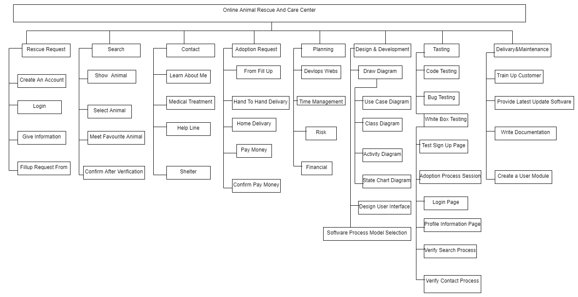

**Constructive cost model for ‘Online animal rescue and care center’**

Here, our project is organic.

so coefficient is 2.4,

P = 1.05

T= 0.38

source lines of code of this project = 9500 lines

**Effort = PM = Coefficient<Effort Factor>*(SLOC/1000) ^ P**

= 2.4*(9500/1000)^1.05

= 25.52

~ 26 person month (labor working hours)

**Development time = DM = 2.50*(PM) ^T**

= 2.50*(26) ^ 0.38

= 8.62

~ 9 week days

**Required number of people = ST = PM/DM**

= 26/9

= 2.88

~ 3 persons

**TimeLine Charts**



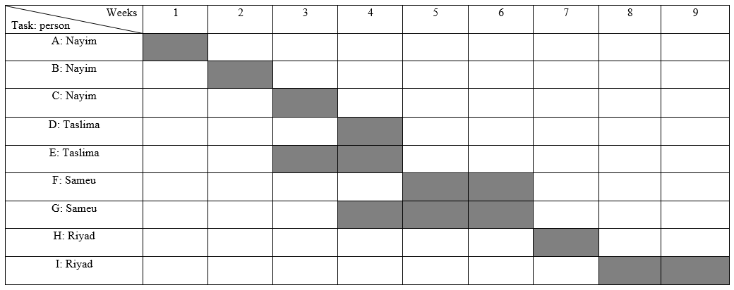

A: Overall Design

B: Process Model Selection

C: Specify Module 1

D: Specify Module 2

E: Create Software WBS

F: Code Module 1

G: Code Module 2

H: Integration Testing

I: System Testing

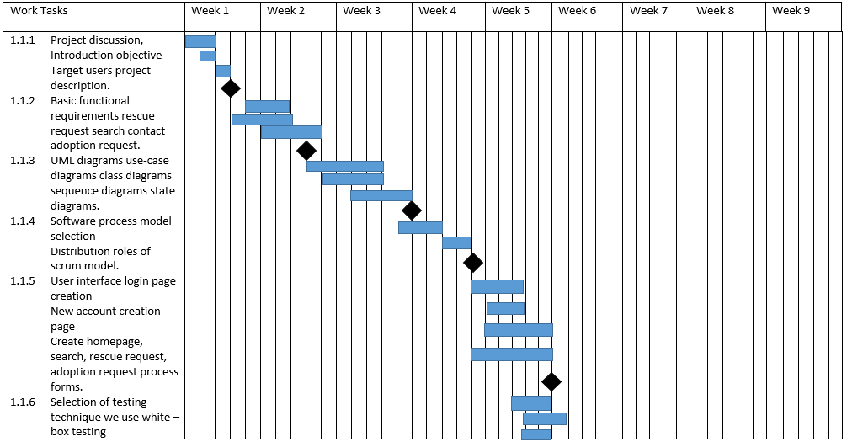 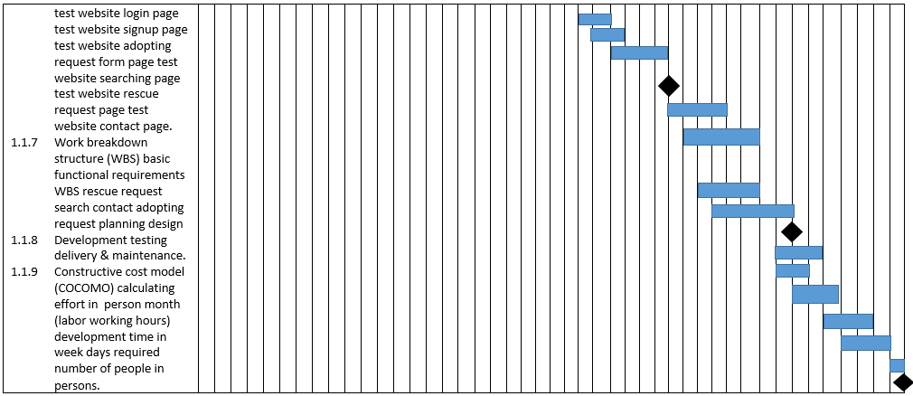

|  |  |  |  |
| --- | --- | --- | --- |
| Risks | category | probability | impact |
| Larger number of users than planned  Size estimate may be significantly low  Less reuse than planned  End user resist system  Delivery deadline will be tightened  Funding will be lost  Customer will change requirements  Technology will not meet expectations.  Lack of training on tools  Staff inexperienced  Staff turnover will be high | PS  PS  PS  BU  BU  CU  PS  TE  DE  ST  ST | 30%  50%  60%  30%  50%  50%  70%  30%  80%  30%  50% | 3  2  2  3  2  1  2  1  3  2  2 |

Risk Table

Impact values:

1- Catastrophic

2- critical

3- marginal

4- negligible